**Curriculum Vitae**

**Personal Information**

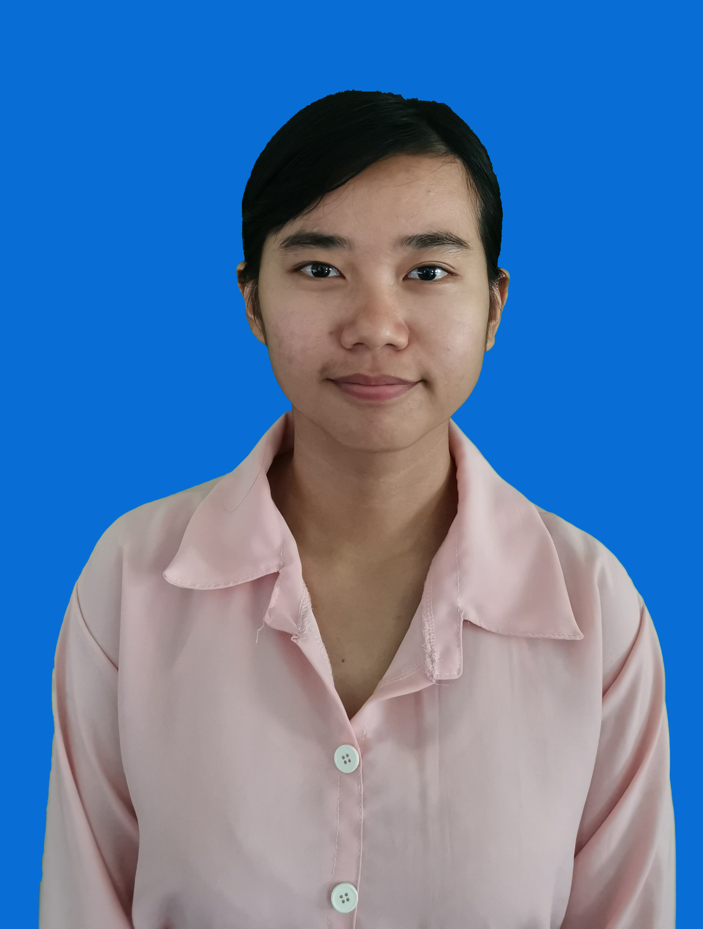

Sivhour Ung

**Address:** Dormitory 1, Mahidol University, 999

St. Phuthamonthon Sai 4, Salaya,

Phuthamonthon, Nakhon Pathom, 73170

**Cell:** (66) 95.190.0884 **Email:** [Sievhourung@gmail.com](mailto:Sievhourung@gmail.com)

**Gender:** Female **Date of Birth:** 16 February 2000 **Nationality:** Cambodian

**Education**

**2011 - 2014:** Angkor Secondary School

**2014 - 2017:** Angkor High School

**2019 – Present:** Sophomore, Faculty of Nursing, Mahidol University (Not yet graduate)

**Work Experience**

**2015-present:** Cloth selling (Family business)

Night Market, Angkor Pyung Yu, St. 60, Siem Reap, Cambodia

**2018:**  English teacher at Australia Education Center

St. 230, Tek Laak 3, Tuol Kok, Phnom Penh, Cambodia

**2019-present:** Mahidol University Christian Club (Member)

Mahidol University, Salaya, Nakhon Pathom, Thailand

**Volunteer Experience**

**April 2016:** Angkor Sangkranta

Union of Youth Federations of Cambodia

Work at the information booth, cooperating with local police station to inform the

emergency needs.

**March 2018** Cycling for Integrity

Transparency International Cambodia

No. 13, St.554, Phnom Penh, Cambodia, 12151

Organized the cycling journey which was 23 kilometers length, stand by at a station

where the participants stopped by and offered them with snacks and drinks. Make

sure that nobody was missing or getting injured.

**February 2019:** Cambodian Stem Education Festival

STEM Cambodia Organization

#97c St 590, Phnom Penh, Cambodia, 12253

Preparing the STEM competition for 3 days, the examinees were high school students.

**February 2019:** Japanese Kizuna Festival

Cambodia-Japan Cooperation Center

Rupp-CJCC, Russian Federation Blvd. (110), Phnom Penh, Cambodia

Help at the Japanese food booth, sharing Japanese food culture and education

**September 2019:** Pchum Ben Festival (Cambodian Traditional Festival)

Wat Sisudaram Varakvihar, Khwaeng Bang Khun Non, Khet Bangkok Noi

Krung Thep Maha Nakhon 10700

Helped with decoration, and also foods for the monks and participants.

**November 2019:** Khmer Dance Performance

Anantara Siam Bangkok Hotel

Perform Chun Por dance (blessing dance) for Cambodian Independence aniversery

event, which was organized by Cambodian Embassy in Thailand.

**Personal Skills**

**Mother Tongue:** Khmer

**Other Languages:**

|  |  |  |  |  |
| --- | --- | --- | --- | --- |
|  | Listening | Speaking | Reading | Writing |
| English | B1 | B1 | A1 | B1 |
| Thai | B1 | B2 | B1 | C1 |
| Chinese | C1 | C2 | B1 | C2 |

Level A1/A2: Proficient user B1/B2: Independent user C1/C2: Basic user

**Communication Skills:**

* I have done voluntary works with many people from different family conditions, communities, and different generations. I also have worked with foreigners from China, Japan, Thailand, Europe, and Africa.
* I am studying abroad in Thailand, where I meet a lot of people from other countries. I have shared the dormitory room with Myanmar, Thais, and Pilipino.

**Organizational Skills:**

* While working for Cycling for Integrity event, I organized the cycling journey and make sure the cyclers safely reached the destination.
* During Pchum Ben festival, my Cambodian students club cooperated with Wat Sisudaram Varakvihar, organized the festival for Cambodian people in Thailand.

**Computer Skills:**

* Competent with most Microsoft Office Program
* E-learning applications such as Google Classroom, Zoom, Cisco Webex